PIZZA SALES SQL QUERIES

**A. KPI’S**

**1.Total Revenue:**

Select SUM(total_price) as total_revenue from pizza_sales; 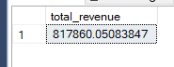

**2. Average order value:**

Select SUM(total_price)/COUNT(DISTINCT order_id) as average_order_value from pizza_sales;

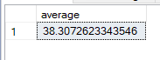

**3. Total Pizza Sold:**

Select SUM(quantity) as Total_pizza_sold from pizza_sales;



**4. Total Orders:**

Select COUNT(DISTINCT order_id) as Total_orders from pizza_sales;



**5. Average Pizza’s per Order:**

Select CAST(SUM(quantity) as DECIMAL(10,2))/ CAST(COUNT(DISTINCT order_id) as DECIMAL(10,2)) as Avg_pizza_per_order from pizza_sales;



**B. CHARTS REQUIREMENT**

**1. Daily Trend for Total Orders:**

Select DATENAME(DW, order_date) as order_day , COUNT(DISTINCT order_id) as Total_orders from pizza_sales Group by DATENAME(DW, order_date);

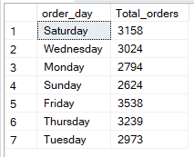

**2. Monthly Trend for Total Orders:**

Select DATENAME(MONTH, order_date) as Month_name,COUNT(DISTINCT order_id) as Total_orders from pizza_sales Group by DATENAME(MONTH, order_date) Order by Total_orders DESC;

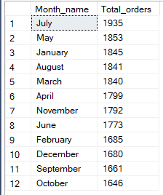

**3. Percentage of Sales by Pizza Category:**

Select pizza_category,SUM(total_price)*100/(Select SUM(total_price) from pizza_sales) as Percent_Total_sales from pizza_sales Group by pizza_category;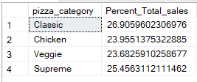

**4. Percentage of Sales by Pizza Size:**

Select pizza_size, SUM(total_price) as Total_Sales , SUM(total_price)*100/(Select SUM(total_price) from pizza_sales) as Percent_sale_by_pizza_size from pizza_sales group by pizza_size order by Percent_sale_by_pizza_size DESC;

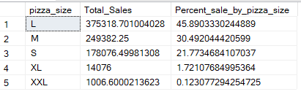

**5. Top 5 Best Sellers by Revenue , Total Quantity and Total Orders:**

Select top 5 pizza_name, SUM(total_price) as Total_Revenue From pizza_sales group by pizza_name order by Total_Revenue DESC;

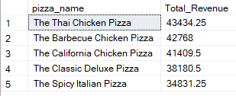

**6. Bottom 5 Best Sellers by Revenue:**

Select top 5 pizza_name, SUM(total_price) as Total_Revenue From pizza_sales group by pizza_name order by Total_Revenue ASC;

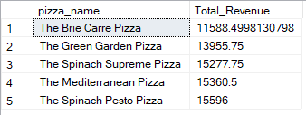

**7. Top 5 Best Sellers by Quantity:**

Select top 5 pizza_name, SUM(quantity) as Total_quantity From pizza_sales group by pizza_name order by Total_quantity DESC;

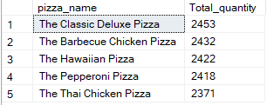

**8. Bottom 5 Best Sellers by Quantity:**

Select top 5 pizza_name, SUM(quantity) as Total_quantity From pizza_sales group by pizza_name order by Total_quantity ASC;

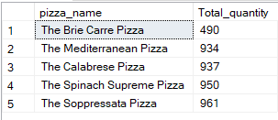

**9. Top 5 Best Sellers by Orders:**

Select top 5 pizza_name, COUNT(DISTINCT order_id) as Total_Order From pizza_sales group by pizza_name order by Total_Order DESC;

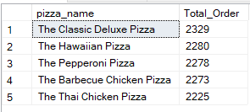

**10. Bottom 5 Best Sellers by Orders:**

Select top 5 pizza_name, COUNT(DISTINCT order_id) as Total_Order From pizza_sales group by pizza_name order by Total_Order ASC;

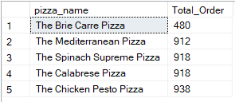

11. Total Pizza Sold by Pizza Category:

Select pizza_category,SUM(quantity) as Total_Quantity_Sold from pizza_sales where MONTH(order_date)=2 group by pizza_category order by Total_Quantity_Sold desc;

